REPORT OF INDIVIDUAL DESIGN PROJECT INTAKE 37

SMART BABY CRADLE

BY

HTM MADHUSHANKA C/ENG/20/5871/ET



BACHELOR OF SCIENCE IN ENGINEERING IN ELECTRONICS & TELECOMMUNICATION

GENERAL SIR JOHN KOTELAWALA DEFENCE UNIVERSITY 2021

# ABSTRACT

The current number of working mothers has greatly increased. Subsequently, baby care has become a daily challenge for many families. Thus, most parents send their babies to their grandparents’ house or to baby care houses. However, the parents cannot continuously keep an update their babies’ conditions either in normal or abnormal situations. Therefore, an Internet of Things-based Smart Baby Cradle System is proposed as an efﬁcient and low-cost IoT-based system for monitoring in real time. I have proposed a new algorithm for my system that plays a key role in providing better baby care while parents are away. In the designed system, Node Micro-Controller Unit (NodeMCU) Controller Board is exploited to gather the data read by the sensors and uploaded via Wi-Fi to the Blynk application server. The proposed system exploits sensors to monitor the baby’s vital parameters, such as ambient temperature, humidity, and crying. The system architecture consists of a baby cradle that can control swinging using a single mobile application when the baby cries. Parents can also monitor their babies' condition through an external camera and switch on the mini fan or play the baby's favorable sound clip and also parents can listen the sound through a microphone located on the baby cradle remotely via the blynk app server to entertain the baby.

# 

# TABLE OF CONTENTS

ABSTRACT 2

TABLE OF CONTENTS 3

LIST OF TABLES 5

LIST OF FIGURES 6

CHAPTER 1: INTRODUCTION 7

* 1. BACKGROUND OF STUDY 7

1.2 PROBLEM STATEMENT 8

CHAPTER 2: PRODUCT SURVEY 9

* 1. AVAILABLE SMART BABY CRADLE 9
  2. GAPS FOUND IN THE EXISTING PRODUCTS 11

CHAPTER 3: OBJECTIVES AND AIMS 12

CHAPTER 4: METHODOLOGY 13

* 1. HARDWARE AND SOFTWARE REQUIREMENTS 13
  2. MATERIAL SELECTION 14
  3. CIRCUIT DEVELOPMENT 14
  4. COMPONENTS SELECTION 14
     1. SOUND SENSOR 14
     2. TEMPERATURE AND HUMIDITY SENSOR 15
     3. V380 BULB CAMERA 16
     4. ESP8266 WI-FI MIDULE 16
     5. DC MOTOR 17
     6. MOTOR CONTROLLER 18
     7. MINI FAN 19
     8. POWER SUPPLY 19
  5. PROTOTYPE DESIGN 20
  6. WORKING PRINCIPAL 22
  7. COST BREAKDOWN 23

CHAPTER 5: FINAL OUTCOME AND DISCUSSION 24

* 1. FINAL OUTCOME 24
  2. ENCOUNTERED PROBLEMS AND IMPLEMENTED SOLUTIONS 26
  3. PRODUCT SPECIFICATIONS 26
  4. LIMITATIONS 27
  5. DISCUSSION 27

CHAPTER 6: CONCLUSIONS AND FUTURE WORK 28

* 1. CONCLUSION 28
  2. FUTURE WORK 28

REFERENCES 29

ANNEXTURE 2 – USER’S MANUAL

# LIST OF TABLES

Table 1: Gaps found in the Existing Products 11

Table 2: Hardware and Software Requirements 13

Table 3: Cost Breakdown 23

# LIST OF FIGURES

Figure 1: Sound Sensor 15

Figure 2: DHT11 Sensor 15

Figure 3: V380 Bulb Camera 16

Figure 4: ESP8266 Wi-Fi Module 17

Figure 5: DC Motor 18

Figure 6: Motor Controller 18

Figure 7: 12V Mini Fan 19

Figure 8: Power Supply 19

Figure 9: Cradle fixed Position 20

Figure 10: Removable as portable Position 20

Figure 11: Smart Cradle Final Prototype 24

Figure 12: Bulb Camera Output 25

Figure 13: Blynk Application Interface 25

# CHAPTER 1: INTRODUCTION

## BACKGROUND OF STUDY

The advent of urbanization has increased the percentage of working women. Women who are basically known for multitasking undergoes a very tough time in taking care of their babies. Those moms who are excessively occupied and do not having baby sitter to deal with their infants find it difficult to take care the baby. The parents who cannot afford costliest comfortable cradles have to swing the conventional cradle to make the baby sleep. On the other hand, people who could afford costliest cradle are not happy with the features provided. To add on the infants do have certain discomforts. Inventing smart, powerful and profitable products to satisfy the needs and expectations of the market and then turning the insights that emerge into ideas that deliver change is more important than creating junk or crap. Here, I am trying to soothe the baby's distress and to serve as a helping hand for the parents.

## PROBLEM STATEMENT

Under fast-paced life conditions, everyone is busy in their professional life including parents. They leave the house early in the morning and come back before dinner time. Even the mothers are working. Thus, they do not have enough time to take care of their babies. Then, after working for long hours, the mothers still have to manage the house and to take care their babies simultaneously. Parents might not have time to soothe their baby to sleep or rock their baby back to sleep in the middle of the night. Studies about the effect of rocking a baby have been carried out and found that babies sleep better while being rocked or swung lightly because the rhythmic movement mimics the gentle rocking they felt while they are in their mothers’ womb. Most available automated cradles are designed to rock non-stop. However, the rocking movement can make the baby nauseous and uncomfortable. Thus, allowing the automated cradle to rock the baby to sleep in the middle of the night is also a problem. Furthermore, some parents place their baby in a separate room. Therefore, parents could not hear the baby's crying and could not be there to ease their baby back to sleep in the middle of the night. Other parents may be occupied with house chores. Thus, because they cannot hear their baby's crying, they cannot attend to them immediately. Sometimes, the baby only needs a little distraction to return to deep sleep. Several types of baby cradles are available in stores, but they are expensive, and not everyone can afford them. In addition, the existing automatic cradles in the literature have many limitations in terms of functionality, cost, and communication technology support. To overcome these problems, IoT-based smart baby cradle system is designed, which parents can easily use a single mobile application to monitor the baby’s condition and they can give a better solution for them anywhere and anytime.

# CHAPTER 2: PRODUCT SURVEY

## AVAILABLE BABY CRADLES

## There are few existing products like “Intelligent baby cradle”, “Smart baby cradle”, “Electric baby

## Cradle”. These products are kind of conventional models where in they use a only constant mechanism

## to soothe the baby's distress. The method of swinging the cradle follows an East to West mechanism

## to calm the baby. More expensive is one of the disadvantages of these products.

* + 1. Mastela 3 in 1 Deluxe Multifunctional Baby Cradle

The Mastela deluxe multipurpose cradle is the most widely used in the world and is made to swing automatically and can be controlled remotely. This electric cradle is a portable cradle and has an audio device system that comforts the baby. The disadvantage of this type of cradle is that it is more expensive and has no more features to calm the baby.

* + 1. Multi-function Intelligent Electric rocking baby cradle

This type of cradle can be set a short distance and placed on a short area. It has a five-speed timer for swinging and a music clip to calm the baby. The main disadvantage of this product is that there is no camera system to watch the child when the parents are not present.

* + 1. MamaRoo 4 Multi-Motion Baby Cradle

This cradle is only a baby swing that recreates the natural movements of the parents. It swings up and

down and sways from side to side, just like parents do. The main disadvantage of this product is that

it has the only the swing mechanism to comfort the baby.

* + 1. Fisher-Price Sweet Snugapuppy Dreams Cradle

Fisher price sweet snugapuppy dreams cradle has dual-motion, puppy-themed baby swing sways side to side or head to toe with music, sounds and motorized mobile. It can be customized with 6 swing speeds, 16 songs and sounds and adjustable seat recline. Overhead mobile with dome mirror and 3 soft toys help entertain baby. And also this cradle can be easily washable and plush sheet pad with deluxe sweet snugapuppy body cushion insert and head support. Not having a camera system to watch the baby when the parents are not present is a main disadvantage of this product.

.

* + 1. Star Daisy Electric Cradle

This type of electrical cradle is primarily designed for the ease of usage and is frequently used in limited spaces. It has a 5 gear automatic swing and a hand pushed control system. It imitates parents’ hand push more accurately with electricity and gives the freedom to control the speed of the swing to soothe their baby and let him feel in their arms. Have the freedom to keep doing their stuffs while ensuring their baby is at comfort all the time. If the swing speed is not fit or the music is too loud, it can be adjusted it at ease with the wireless remote control. We know there is no replacement to mother’s care in this world but this product tries to make efforts to imitate this care and love using the bionic mother technology and the main disadvantage is the product is more expensive.

## GAPS FOUND IN THE EXISTING PRODUCTS

Table 1: Gaps found in the Existing Products

|  |  |  |  |  |  |  |
| --- | --- | --- | --- | --- | --- | --- |
| Product Name | Automatically Swinging | Soothing Methods used (Fan, Audio devices) | Monitoring system used (Camera) | Sensors used | Ease of using | Price (LKR) |
| Multi-function Intelligent Electric rocking baby cradle | Yes | Yes, Songs and Sounds | No | Yes | Easy | 48,000 |
| Fisher-Price Sweet Snugapuppy Dreams Cradle | Yes | Yes | No | No | Medium | 34,000 |
| Mastela 3 in 1 Deluxe Multifunction Baby Cradle | Yes | No | No | No | Easy | 28,000 |
| Star Daisy Electric Cradle | Yes | Yes | No | No | Easy | 24,000 |

# CHAPTER 3: OBJECTIVES AND AIMS

AIM:

To make a smart, an efficient and low cost baby cradle which has an ability to detect any behaviors of babies and useful for the parents with busy lifestyle for looking after their babies from any distance.

OBJECTIVES:

* To implement a design which has an ability to monitor baby’s every movements, background temperature and humidity.
* To facilitate continuous identification of every activity of the child and provide them with a better solution from any distance.
* To make a cradle innovation that is more efficient and less expensive to any different culture of parents.

# CHAPTER 4: METHODOLOGY

Prototype hardware development and software development are the two main elements of the system. The project's hardware construction entails making a prototype out of the materials specified. The software building, on the other hand, is accomplished by utilizing the Arduino IDE software to create and simulate the circuit.

## HARDWARE AND SOFTWARE REQUIREMENTS

Table 2: Hardware and Software Requirements

|  |  |
| --- | --- |
| Component Name | Function |
| NodeMCU | To receive and upload data to the server with the embedded Wi-Fi module |
| DC Motor | To swing the cradle |
| Motor Controller | To control the direction and speed of the motor |
| Sound Sensor | To detects baby’s crying sound |
| Temperature and Humidity Sensor | To detect the temperature and humidity levels at the background of cradle system |
| Camera Module | To monitor the baby’s every movements |
| Box Bars/ Metal Bars | To construct the framework of a cradle |
| Mini Fan | To provide cooling to the baby |
| Power Supply | To provide supply for all devices |
| Arduino IDE | To program the whole circuit according to the specifications |
| Blynk Application | To control the all the devices and get the information from the sensors |
| SOLIDWORKS | To design the 3D model of the prototype |
| Proteus Software | To design the schematic diagram of the circuit |

## MATERIAL SELECTION

When selecting the materials suitable for the product the main concerns were to design the product which is durable, can hold a certain weight, so that it can be swing easily, and a frame that can be portable and foldable. Therefore, as the optimal solution, aluminum box bars were chosen which satisfied all the requirements. Cotton cloths could also be used because of their comfort given to the baby and cheap price, although designing process will be complex if it is used.

## CIRCUIT DEVELOPMENT

The Baby cradle system created for this project can control using a Blynk application and monitor the baby through an external camera. The system is built using a few electrical components such as a Node Micro-Controller Unit (NodeMCU), sensors, mini fan and a dc motor.

## COMPONENTS SELECTION

* + 1. SOUND SENSOR

The sound sensor is used to detect the sound of the baby’s cry then will automatically send a notification to the blynk application via Node Micro-Controller Unit (NodeMCU).

Figure 1: Sound Sensor

* + 1. DHT SENSOR

DHT sensor is used to measure the temperature and humidity of the cradle. The main aim of using DHT sensor is to get the current temperature of the atmosphere around the baby. For instance, the temperature is above 22 degree it causes a discomfort to the baby, that time the parent can pay attention to the baby by swinging the cradle through the mobile application.

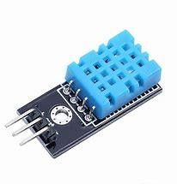

Figure 2: DHT11 Sensor

* + 1. V380 BULB CAMERA

V380 Bulb camera is a low cost and easy to use Wi-Fi camera and also it have a speaker and a microphone, parents can play a baby’s favorable sound clip or they can listen to the baby’s voice while they are away and it has a Led Night Vision technology, high quality 2MP 1080P HD live video for no matter day and pitch dark. Bulb camera will alert on user’s smart device when motion is detected, get informed about every movement in this cradle. Specially, the parent will be able to speak to the child through the mobile application which is connected to the camera. The parent will be able to see the child live on his/her mobile application.

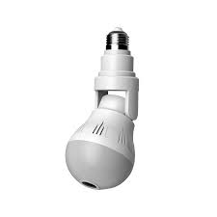

Figure 3: V380 Bulb Camera

* + 1. ESP8266-WIFI MODULE

The ESP8266 is a low cost Wi-Fi microchip with full TCP/IP stack and microcontroller capability. This small module allows microcontrollers to connect to a Wi-Fi network and make simple TCP/IP connections using Hayes-Style command.

A Wi-Fi module is used to connect the sensors of the cradle system to the Blynk cloud services via Arduino.

Figure 4:ESP8266-WIFI MODULE

* + 1. DC MOTOR

Electric motor is a machine which converts electrical energy to mechanical energy. Its action is based on the principle that when a current carrying conductor is placed in a magnetic field, it experiences a magnetic force whose direction is given by Fleming’s left hand rule. When a motor is in operation, it develops torque. This torque can produce mechanical rotation. DC motors are also like generators classified into shunt wound or series wound or compound wound motors. Here, I have used a 775 12V dc motor for swinging the baby cradle. It can be controlled swinging speed using Blynk application. The 775 model of DC motor represents a certain ‘size’ of the motor body outer frame. This size is standard for all 775 motors. 775 is the size ID of motor accepted as a standard.

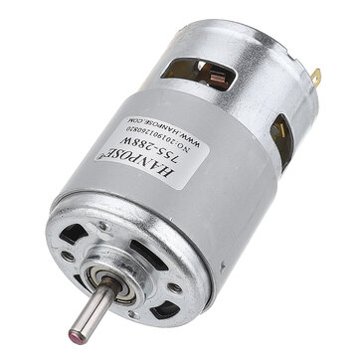

Figure 5: 775 DC Motor

* + 1. MOTOR CONTROLLER

Motor controller is a device or group of devices that can coordinate in a predetermined manner the performance of an electric motor. A motor controller might includes a manual or automatic means for starting and stopping the motor, selecting forward or reverse rotation, selecting and regulating the speed, regulating or limiting the torque, and protecting against overloads and electrical faults.

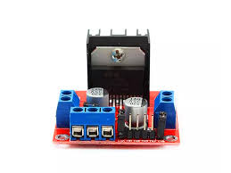

Figure 6: Motor Controller

* + 1. MINI FAN

It can be used as a cooling fan for the baby. Parents can control via Blynk application server,

When the baby is crying parents can switch ON the mini fan or else switch OFF.

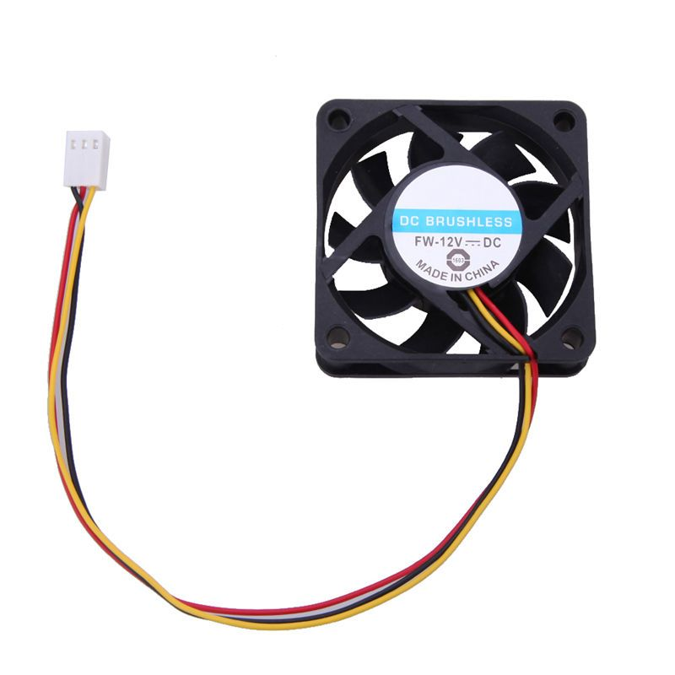

Figure 7:12V Mini Fan

4.4.8 POWER SUPPLY

Power supply is the hardware component that provides electricity to motor, mini fan, NodeMCU and other

devices. It converts electrical current pulled from a power source, such as an outlet, battery or generator, to

the correct format and passes it on to a device.

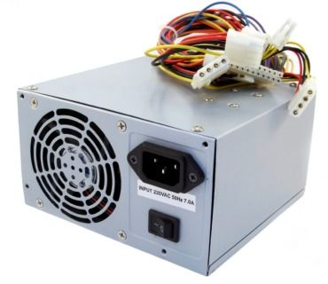

Figure 8: Power Supply

## PROTOTYPE DESIGN

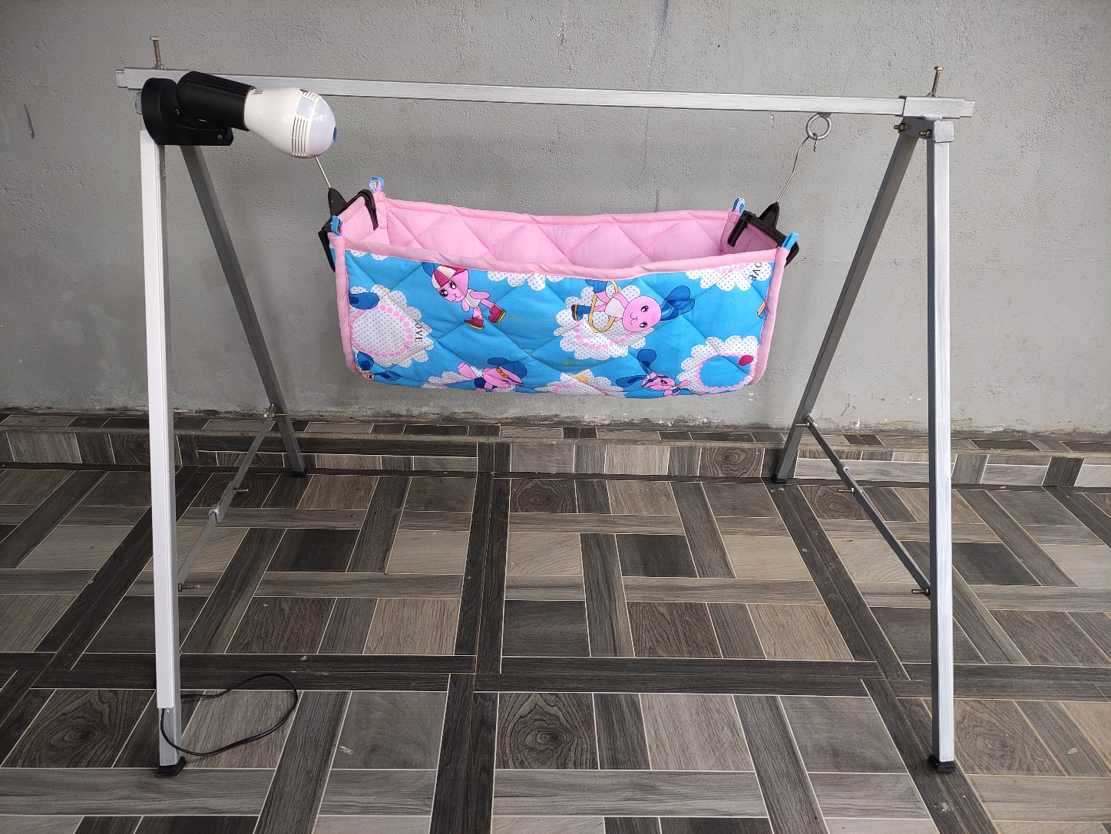

Figure 9: Cradle fixed Position

When designing a prototype model, it is designed to be removable, portable and flexible.

* Portable: This designed baby cradle is portable, and easy to adjust.
* Flexible: The cradle is easily bent and stored when not in use or folded to make it easy to carry

anywhere.

Figure 10: Removable as portable Position

## WORKING PRINCIPLE

For transferring the data to server, we need an internet connection, so for this system we are using a smart phone and configure it as access point or hotspot. Once you have configured it as access point you can connect it with ESP8266 NodeMCU. Now with the help of Wi-Fi module all the sensor data are transmitted to the server where the threshold comparison is made. Whenever the baby's cry is detected, mother will automatically receive a notification and they can control the cradle swing by using a DC motor. Now with the help of android application, parents can view the features such as body temperature, moisture content etc. Once they come to know that their baby is suffering from fever, the parents can immediately approach their baby or just make a phone call to the person whom the baby is with. Similarly, if the parents come to know that their baby’s diaper has not been changed for a long period of time, then they can just remind to the care taker and with the help of bulb camera they can continuously monitor and they can listen to the sound of baby through the microphone which has fixed to the camera and mothers also can speak up to the baby from a speaker then it also ensures that the baby is safe in the cradle. Thus, this system helps parents to be free from their worrying thoughts and parents can also work with full concentration without getting distracted.

## COST BREAKDOWN

Table 3: Cost Breakdown

|  |  |
| --- | --- |
| **ITEMS** | **PRICE (LKR)** |
| NodeMCU | 1450 |
| DC Motor, Mini fan, Motor controller | 2000 |
| V380 Bulb Camera | 3500 |
| Metal box bars and Rubber bush | 2500 |
| Cotton cloths and padding sheet | 1400 |
| Sensors | 600 |
| Power supply, connectors | 600 |
| Others | 3000 |
| **Total Cost** | **15050** |

# CHAPTER 5: FINAL OUTCOME AND DISCUSSION

## FINAL OUTCOME

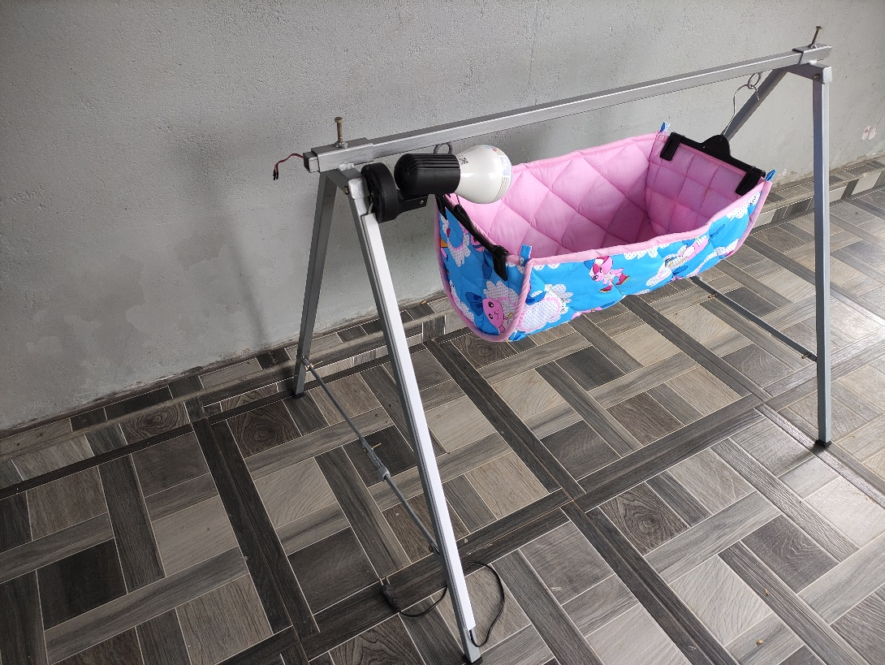A smart baby cradle was implemented which is easily removable as portable and can be easily fix.

Figure 11: Smart Cradle Final Prototype.

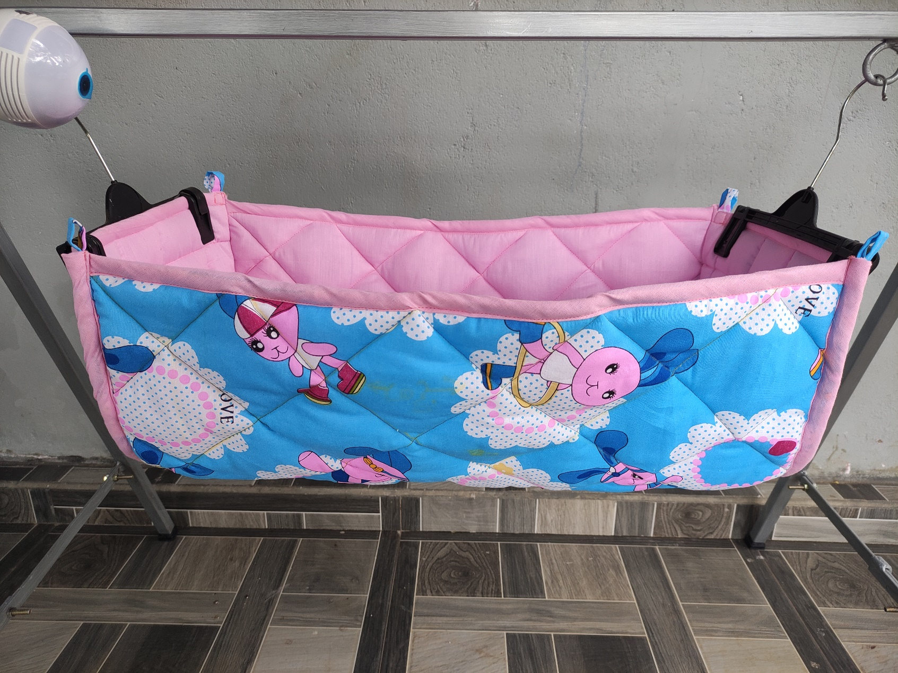

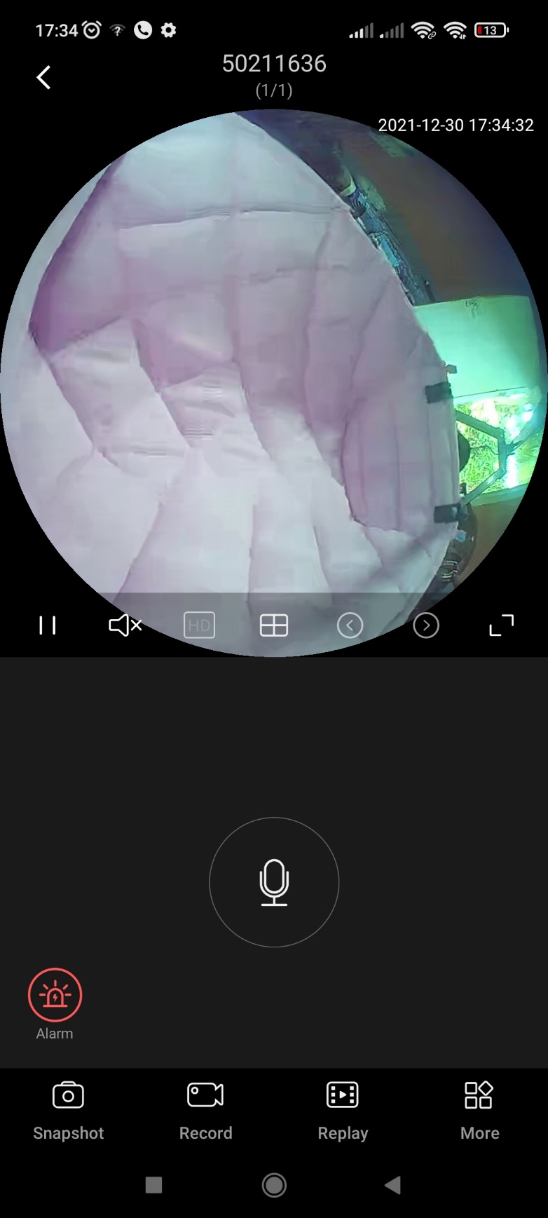

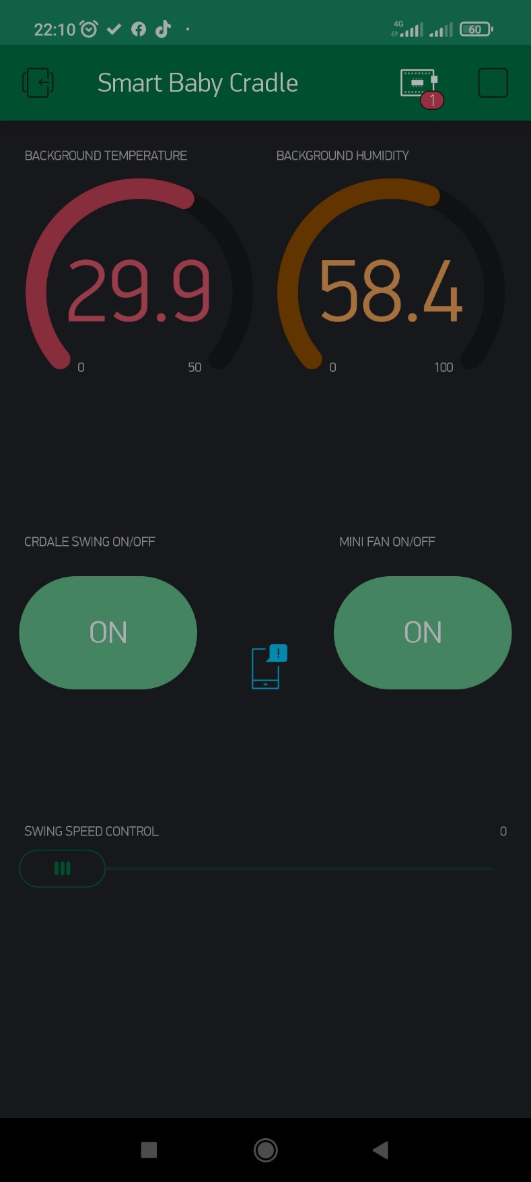

Figure 12: Bulb Camera Output. Figure 13: Blynk Application Interface.

## ENCOUNTERED PROBLEMS AND IMPLEMENTED SOLUTIONS

The Smart Baby Cradle was firstly designed only having a sound sensor to detect a baby's cry and alert the smartphone. However, the sound sensor cannot distinguish a baby's voice or external sound. To solve this problem, it is necessary to use a microphone to check the sound coming from the baby or the sound coming into this system externally.

So, to avoid the above problem I have chosen a V380 Bulb Camera. That means it has not only its camera system but also a microphone, speaker kit and motion detection device. After getting a notification that the baby is crying, the mother can check through the V380 Bulb Camera and also mother can speak up to the baby using this speaker and microphone of the camera and mother can play a baby’s favorable music clip to soothe the baby.

## PRODUCT SPECIFICATIONS

* Dimensions of frame (Overall):100cm(L)*75cm(B)*75cm(H)
* Dimensions of cradle (Overall):60cm(L)*35cm(B)*25cm(H)
* Total Weight: 4.3Kg
* Power Supply: 12V (dc)
* Holds up to: 5 Kg
* Suggested Age: Newborn and up to 6 months
* Features: Multiple Swing Motion, Sounds and Songs, HD Camera Monitoring System, Alert System, Folds for Easy Transport and Storage, Controlled By Smartphone App, Adjustable Speed Setting
* Assembly Details: Adult Assembly Required, No Tools Needed

## LIMITATIONS

This system cannot be automated to use at any event of no internet connection or Wi-Fi and also, the sound sensor cannot be used when playing sound clips or speaker sound of the bulb camera.

## DISCUSSION

Caring for babies is a difficult issue for working parents around the world and for those with busy lifestyles. This system emphasizes the importance of child care. The above designed system is economical and user friendly and very useful for working mothers who have babies less than 6 months. They can efficiently manage their work while caring for their babies. The entire mechanism is mobile, easy to control and easy to observe every movement of the baby from any distance. The advantage of this device is its low start-up cost and low operating cost.

# CHAPTER 6: CONCLUSIONS AND FUTURE WORK

## CONCLUSION

To summarize, looking after babies is a hard problem worldwide. This system emphasizes the importance of child care. The above designed system is economical and user friendly and very useful for working mothers and nurses also. They can manage their work efficiently. This product has developed in a way that it can help parents to keep an update about their babies' any abnormal activities even during normal routine, can be a great help for the families with busy schedules. According to the responses from mothers, this product helps to protect their children from pets or even other people, while the baby is sleeping in the cradle. The main advantage of this model is its low initial cost and low operating cost.

## FUTURE WORK

This product is a business oriented prototype. After the complete development of the product, what remains is the scope for improvements. Firstly, the market analysis should be done, followed by that sales and marketing should be done and also, can be recommended for newborns who are in the hospital, so mothers and nurses can be very helpful in managing their work challenge.

# REFERENCES

1. W. A. Jabbar, H. K. Shang, S. N. I. S. Hamid, A. A. Almohammedi, R. M. Ramli and M. A. H. Ali, "IoT-BBMS: Internet of Things-Based Baby Monitoring System for Smart Cradle," in IEEE Access, vol. 7, pp. 93791-93805, 2019, doi: 10.1109/ACCESS.2019.2928481.
2. N. Saude and P. A. H. Vardhini, "IoT based Smart Baby Cradle System using Raspberry Pi B+," 2020 International Conference on Smart Innovations in Design, Environment, Management, Planning and Computing (ICSIDEMPC), 2020, pp. 273-278, doi: 10.1109/ICSIDEMPC49020.2020.9299602.
3. M. P. Joshi and D. C. Mehetre, "IoT Based Smart Cradle System with an Android App for Baby Monitoring," 2017 International Conference on Computing, Communication, Control and Automation (ICCUBEA), 2017, pp. 1-4, doi: 10.1109/ICCUBEA.2017.8463676.